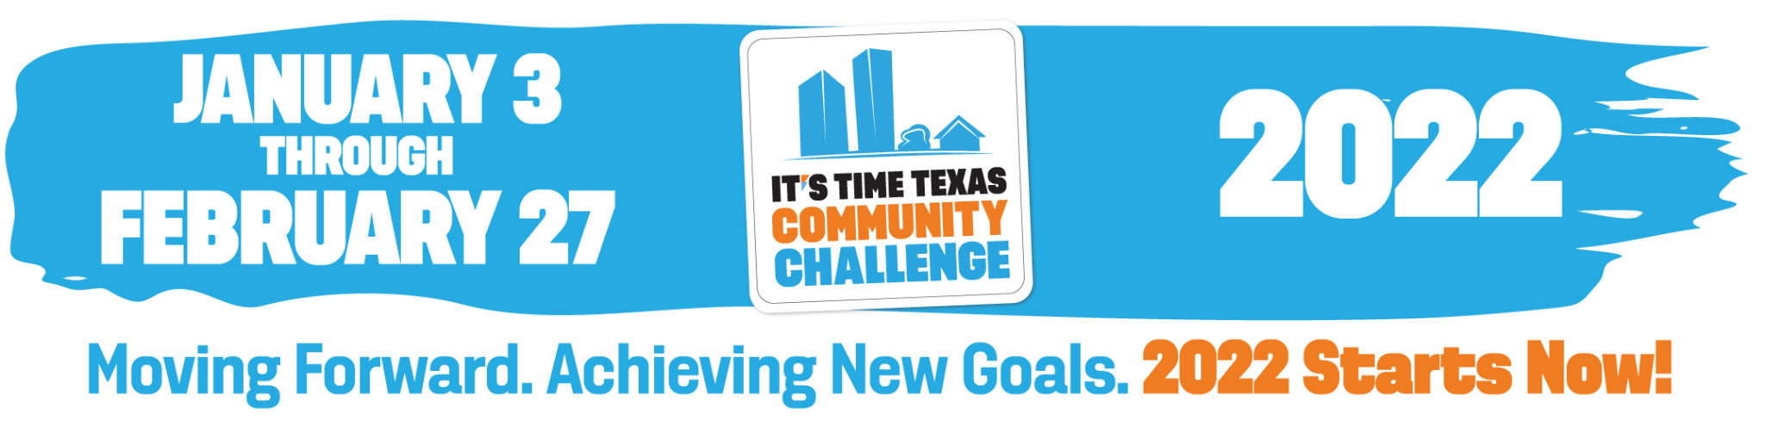

We’re Participating in the 2022 It’s Time Texas Community Challenge!

The It’s Time Texas Community Challenge is a statewide competition that inspires individuals, organizations/employers, and cities across Texas to engage in healthy activities in support of a healthier community. This year, [INSERT COMPANY NAME], has decided to participate in the competition!

It’s FREE and EASY to sign up at Register.ITTCommunityChallenge.com. Be sure to select “yes” under the Employer Challenge section on the registration form and select our company name: [INSERT EMPLOYER NAME]. This ensures your participation will count towards our company’s internal challenge.

After registering online, you will be sent an email from It’s Time Texas with
information on how to download the Community Challenge app (available 12/27) so you can start submitting healthy actions to earn points for our community and prizes for yourself. Let’s win the employer Sub-Challenge, together!

[YOUR LOGO]

